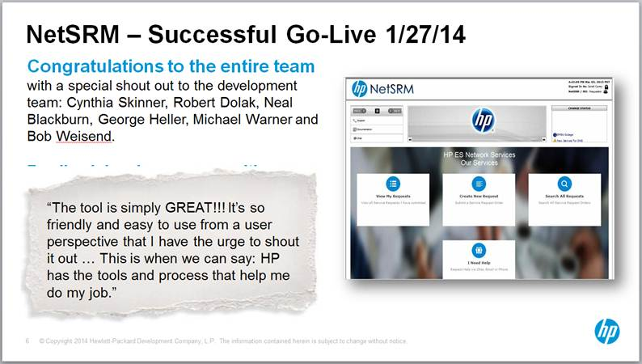

**NetSRM** (Network Service Request Management) is a custom web-based software application using the WAMP stack (Windows, Apache, MySQL, PHP). We used the Zend Framework, which utilizes the MVC design pattern.

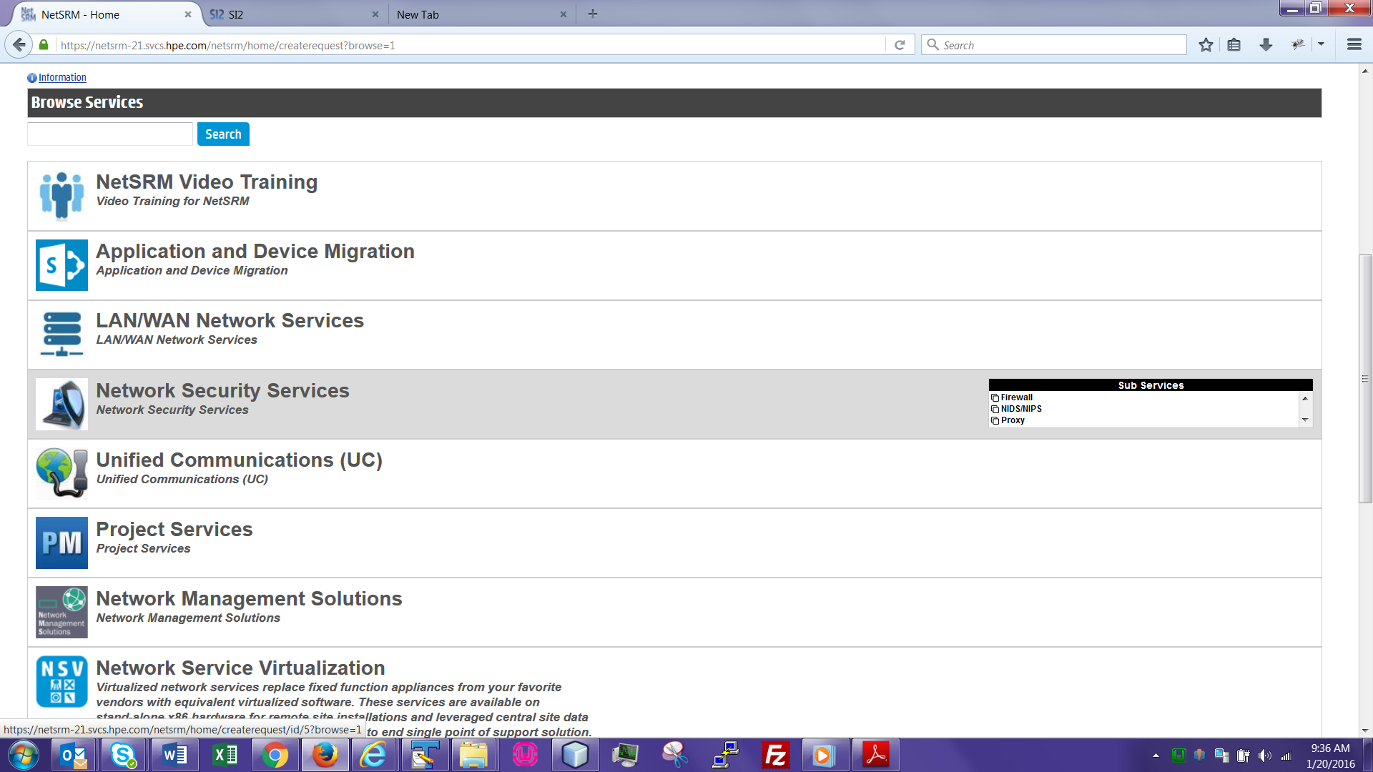

NetSRM provides a catalog of available network services.

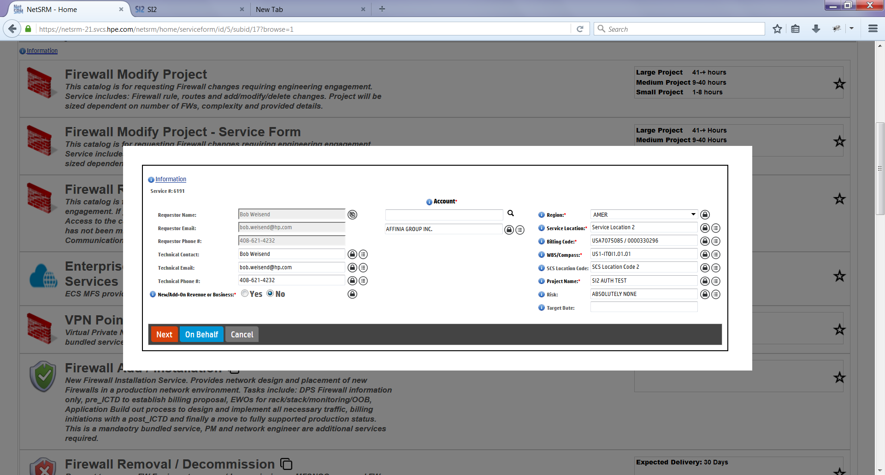

Once a catalog item is selected, the user fills out the service request form. Favorites can be saved so that the form will pre-populate in the future. You can also create a ticket on behalf of another user (e.g. if someone is on a leave of absence).

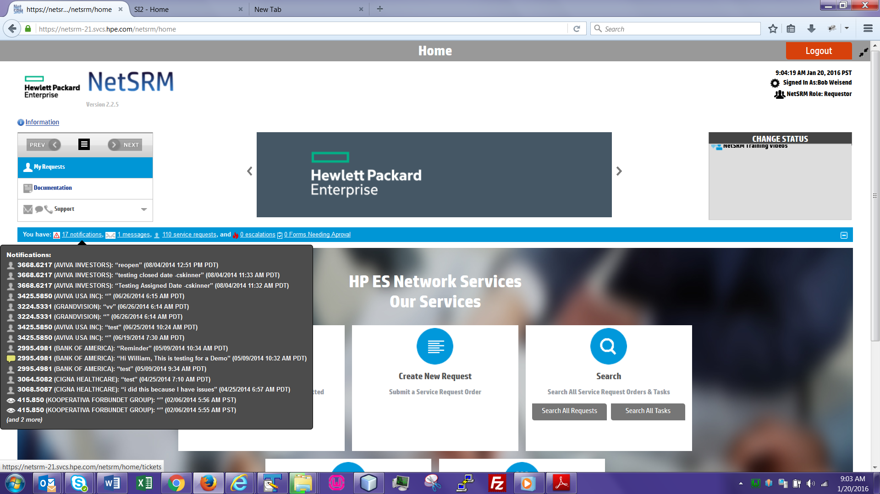

The notification bar appears on every page, providing a quick jump point to a particular service request, message or task. It also provides notifications when certain important events or updates occur.

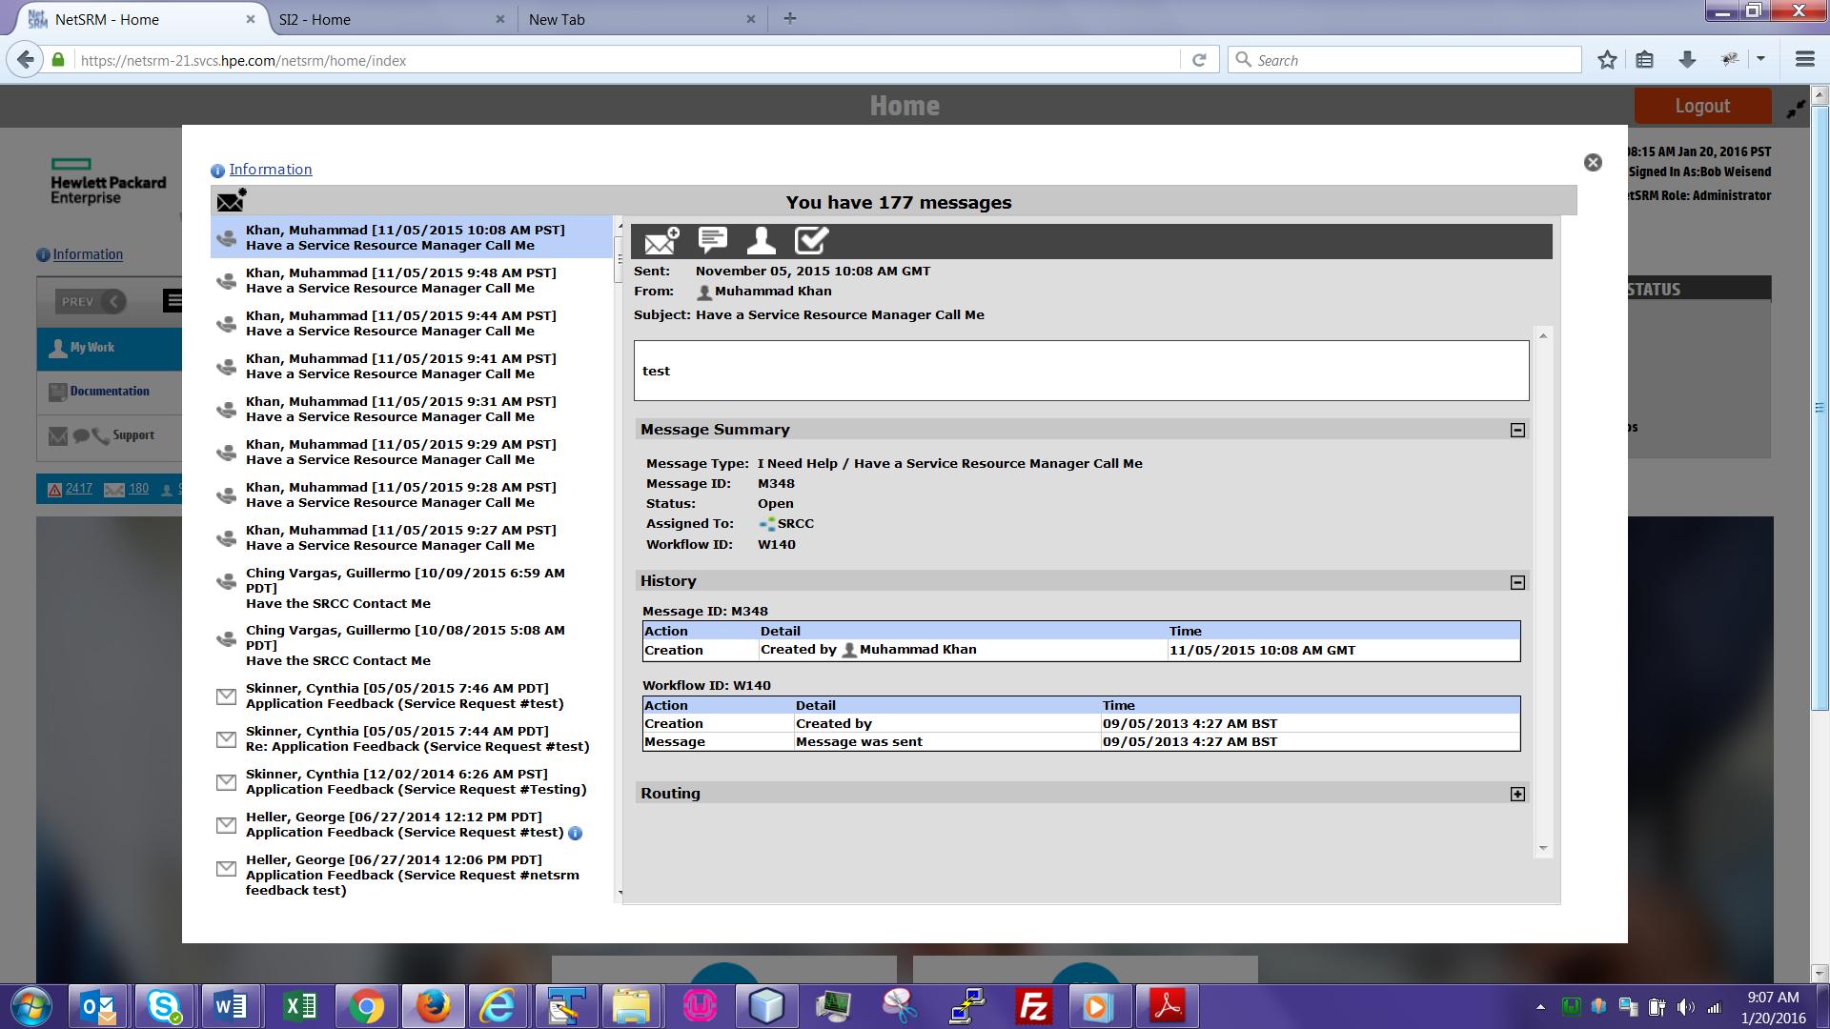

The messaging window works similar to an email client, but with added features such as workflow approvals and task management.

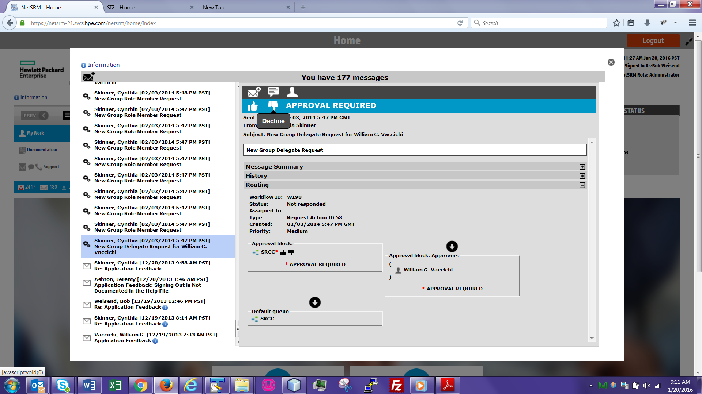

Some messages come with a workflow approval request. If the recipient is designated as an approver, he/she can approve or decline the request and add comments.

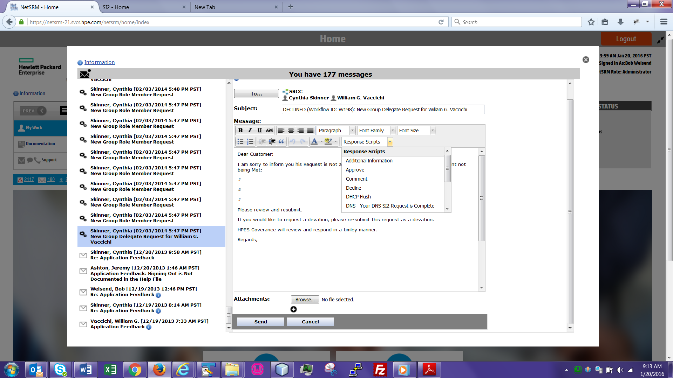

When responding to a message, the user can choose a “Response Script” from the list so he/she doesn’t have to type a custom response every time.

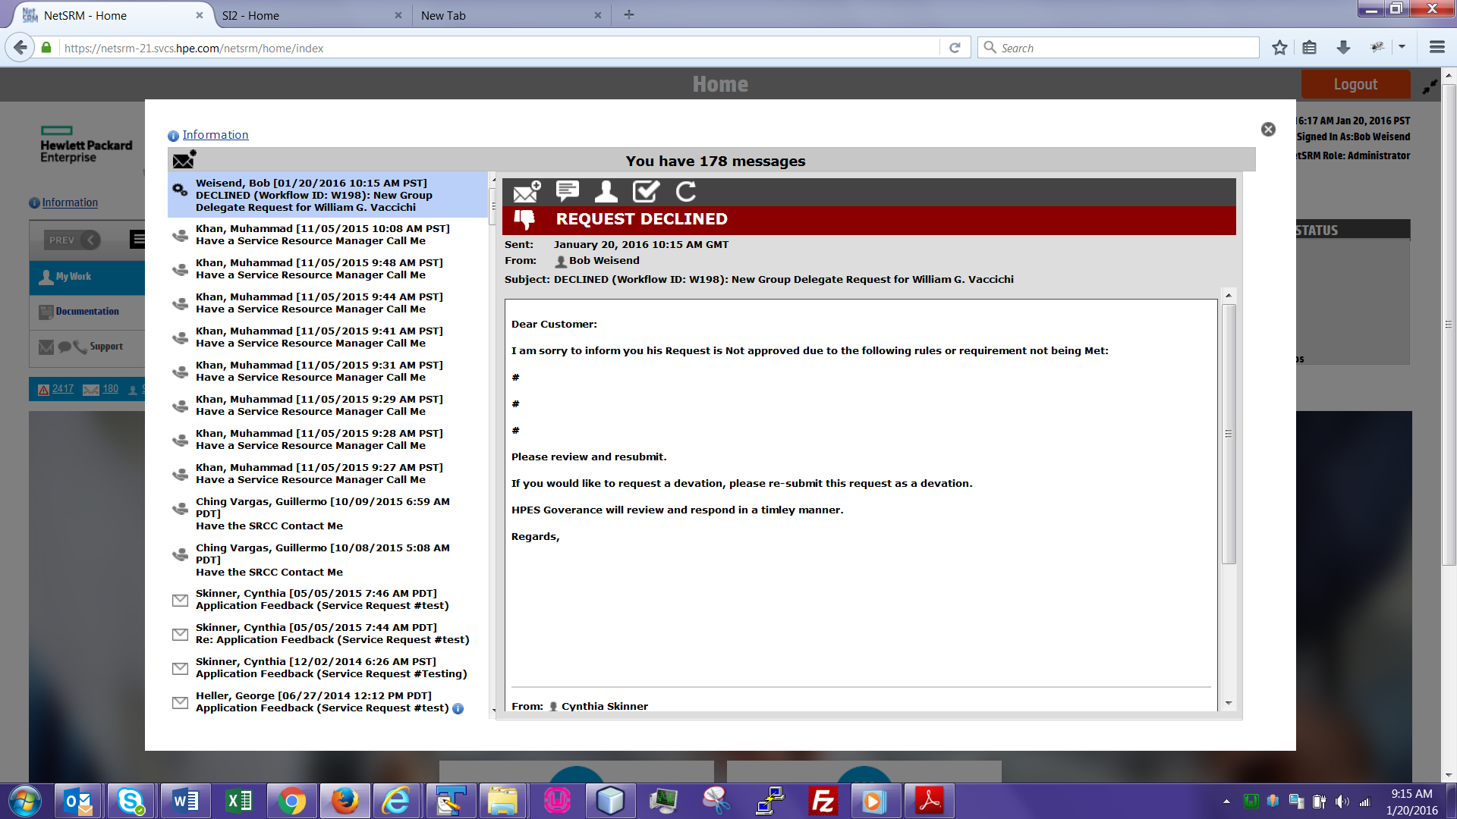

The original requestor receives a message indicating that his/her request has been declined, with the edited Response Script as the message body.

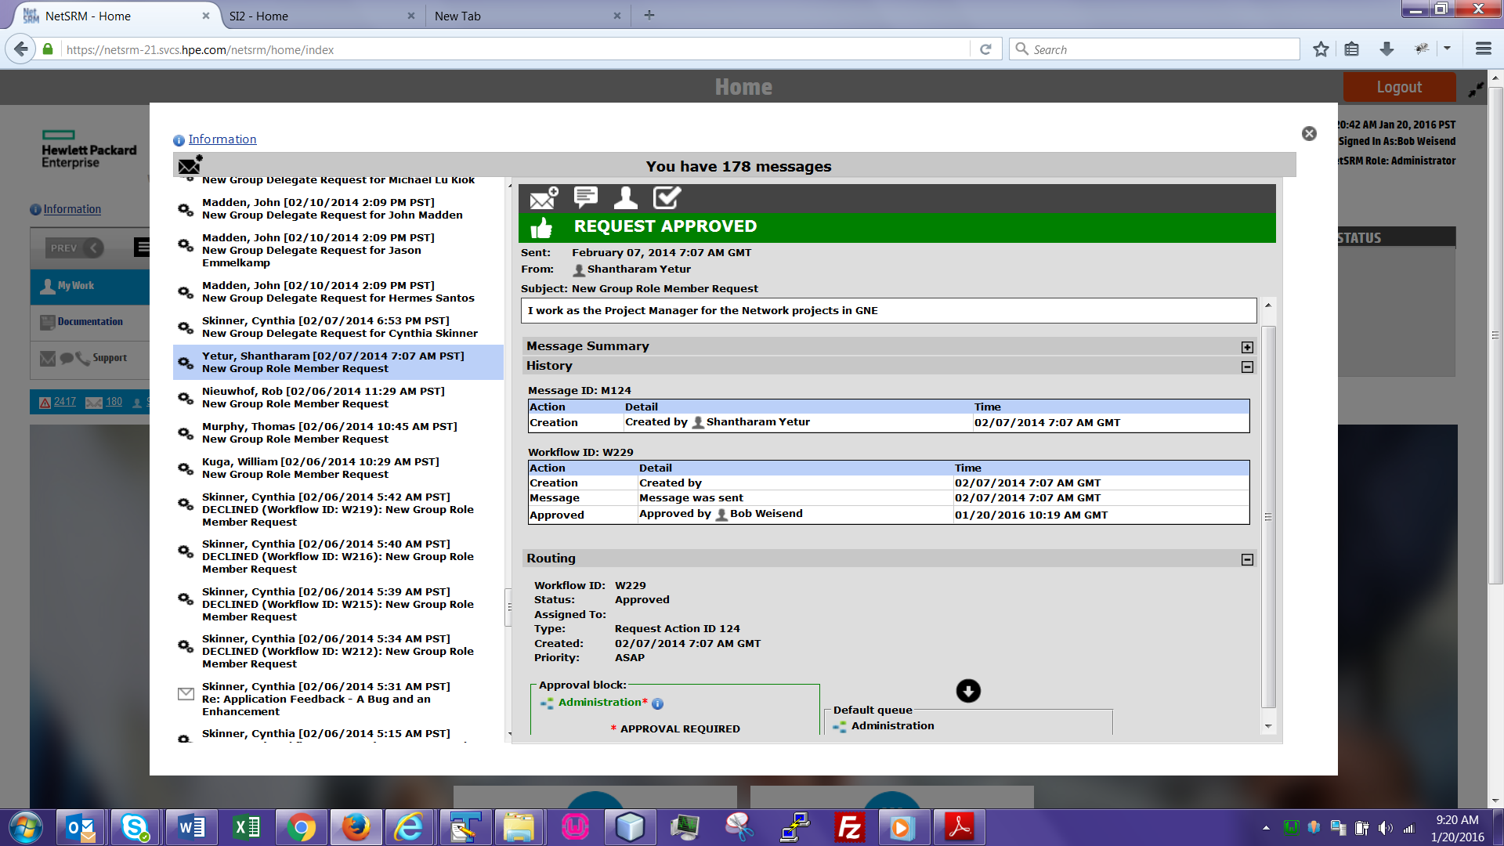

If a workflow request is approved, the associated action (i.e. adding a new role to an existing user) is automatically executed. Automation within NetSRM was a major factor in reducing both resolution times and manual errors.

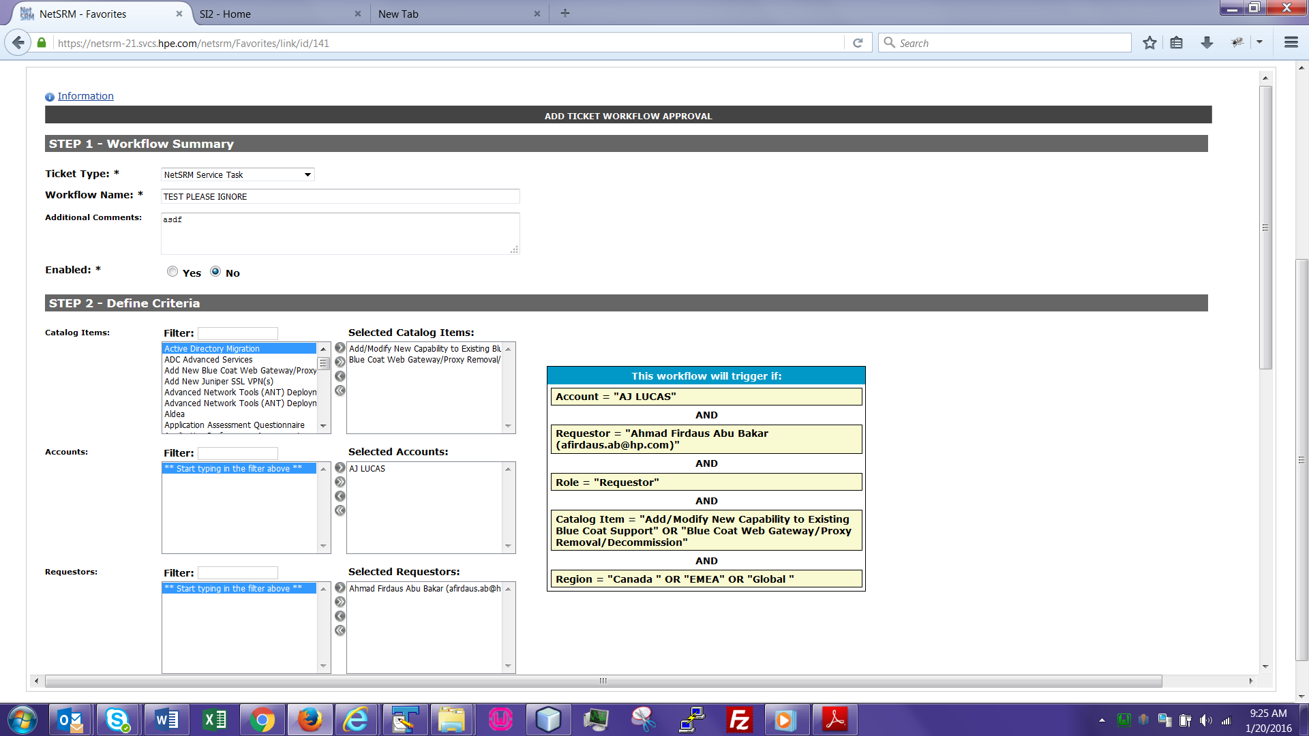

Ticket workflow definitions can be used to add manager approvals if certain criteria are met. For example, if the request is for a specific Account (“AJ LUCAS”) and the request originates from the “EMEA” region, trigger the workflow. The helpful sidebar on the right updates in real time as the user defines the workflow.

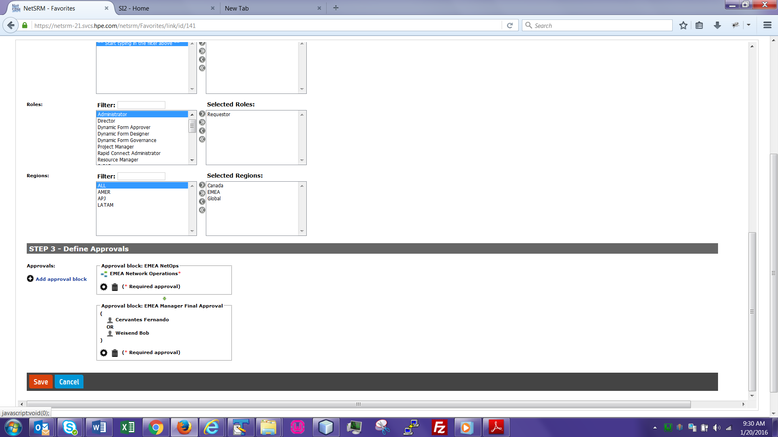

Multiple approval blocks can be defined. In the example above, a member of the “EMEA Network Operations” team must approve first, followed by either Fernando Cervantes or Bob Weisend.

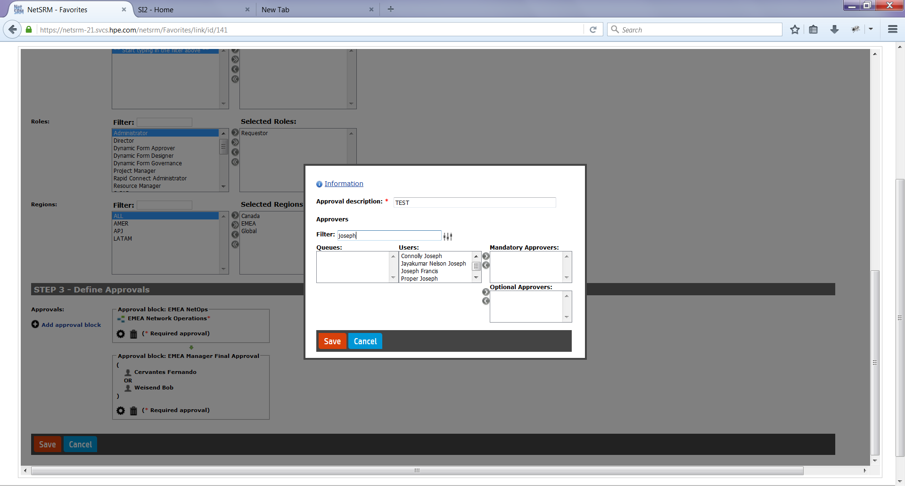

Additional approver blocks can be defined using the modal dialog above. The Filter field can be used to narrow the list of results. Any number of queues (groups) or users can be chosen for a block, and can either be required or optional.

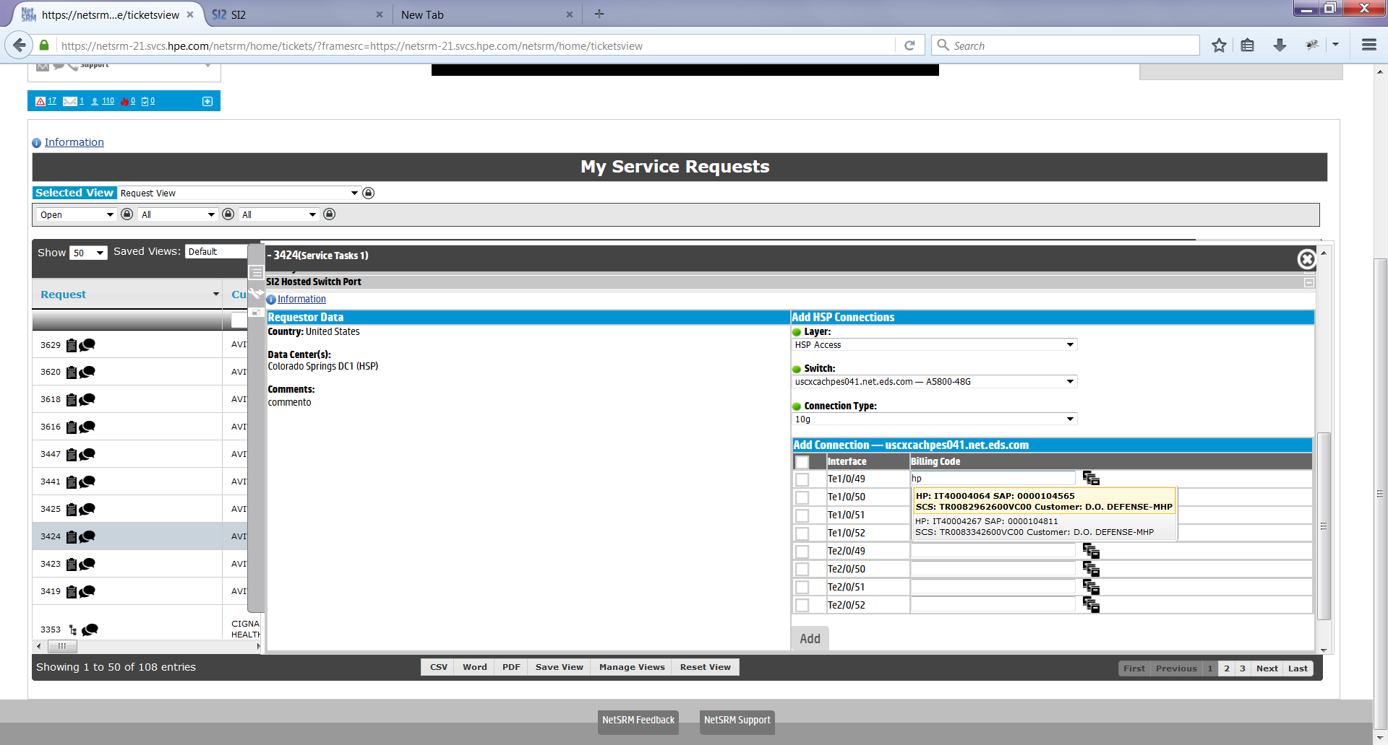

This JQuery plugin (https://flexbox.codeplex.com/) allows the user to type a partial value, then is presented with a list of matching records. When the user stops typing for 1 second, an AJAX call is made which sends the partial text as a parameter, queries the billing code database, and returns the results. The user can simply click on the desired result to automatically populate the text field.

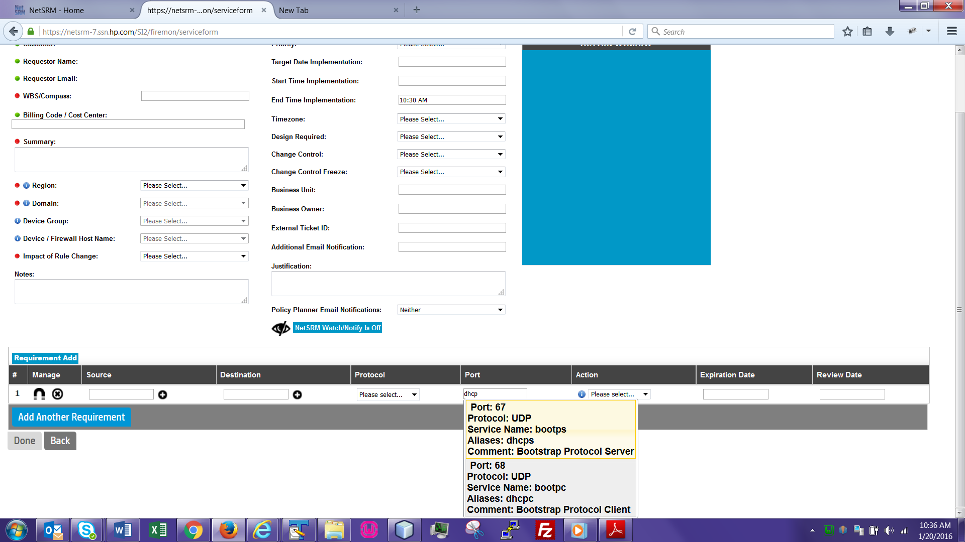

Another implementation for the flexbox. Typing a partial value will make an AJAX call to the port database table. This prevents users from having to memorize or look up the port number for a particular network service.

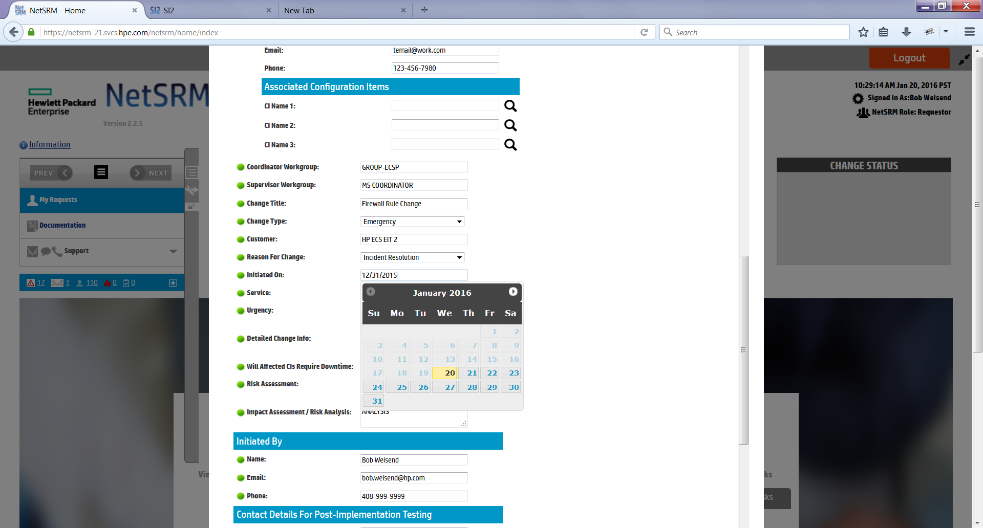

The date picker (JQuery plugin) allows a user to easily choose a date.

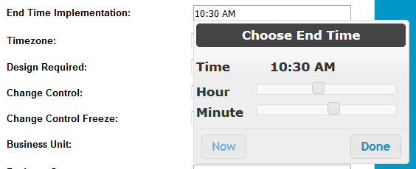

The time picker, similar to date picker.

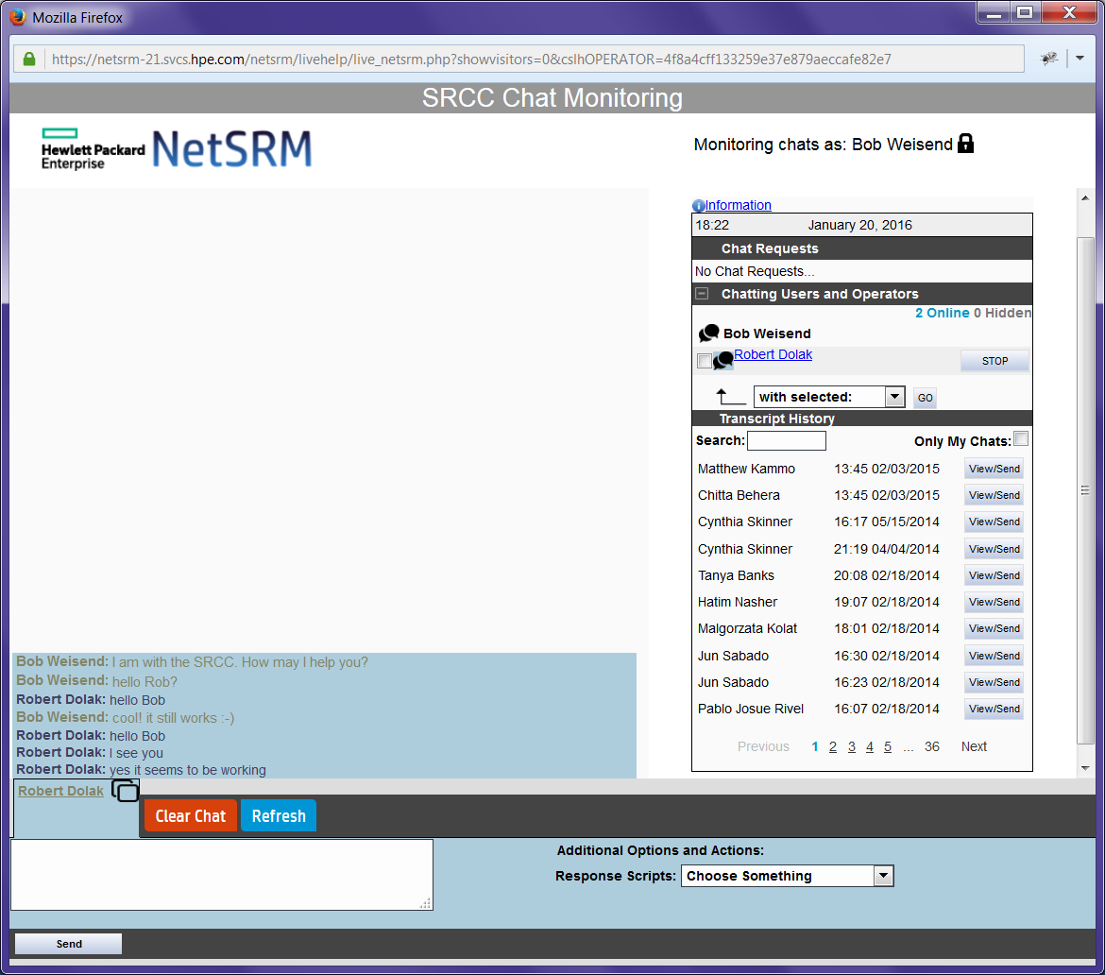

The help desk can monitor chat requests through this interface. It captures the transcript of each session, and the transcript can be emailed to the user.

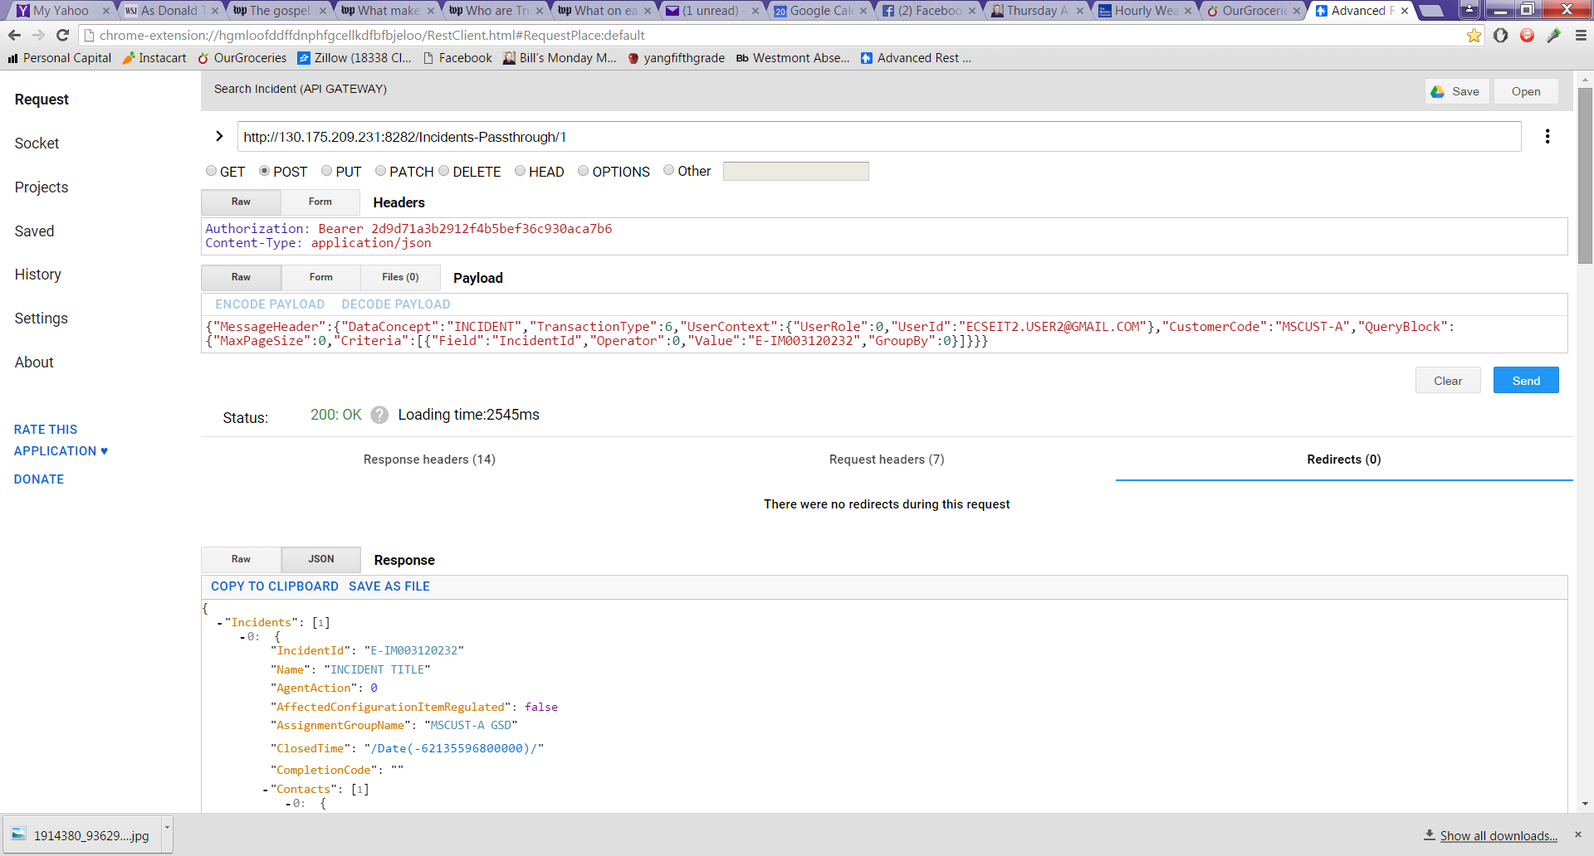

NetSRM interfaces with HP Service Manager (separate ticketing system) using RESTful APIs. The example above shows how NetSRM would pull the details of an INCIDENT ticket using a JSON-encoded message body. NetSRM also has the ability to create new tickets or update existing tickets.

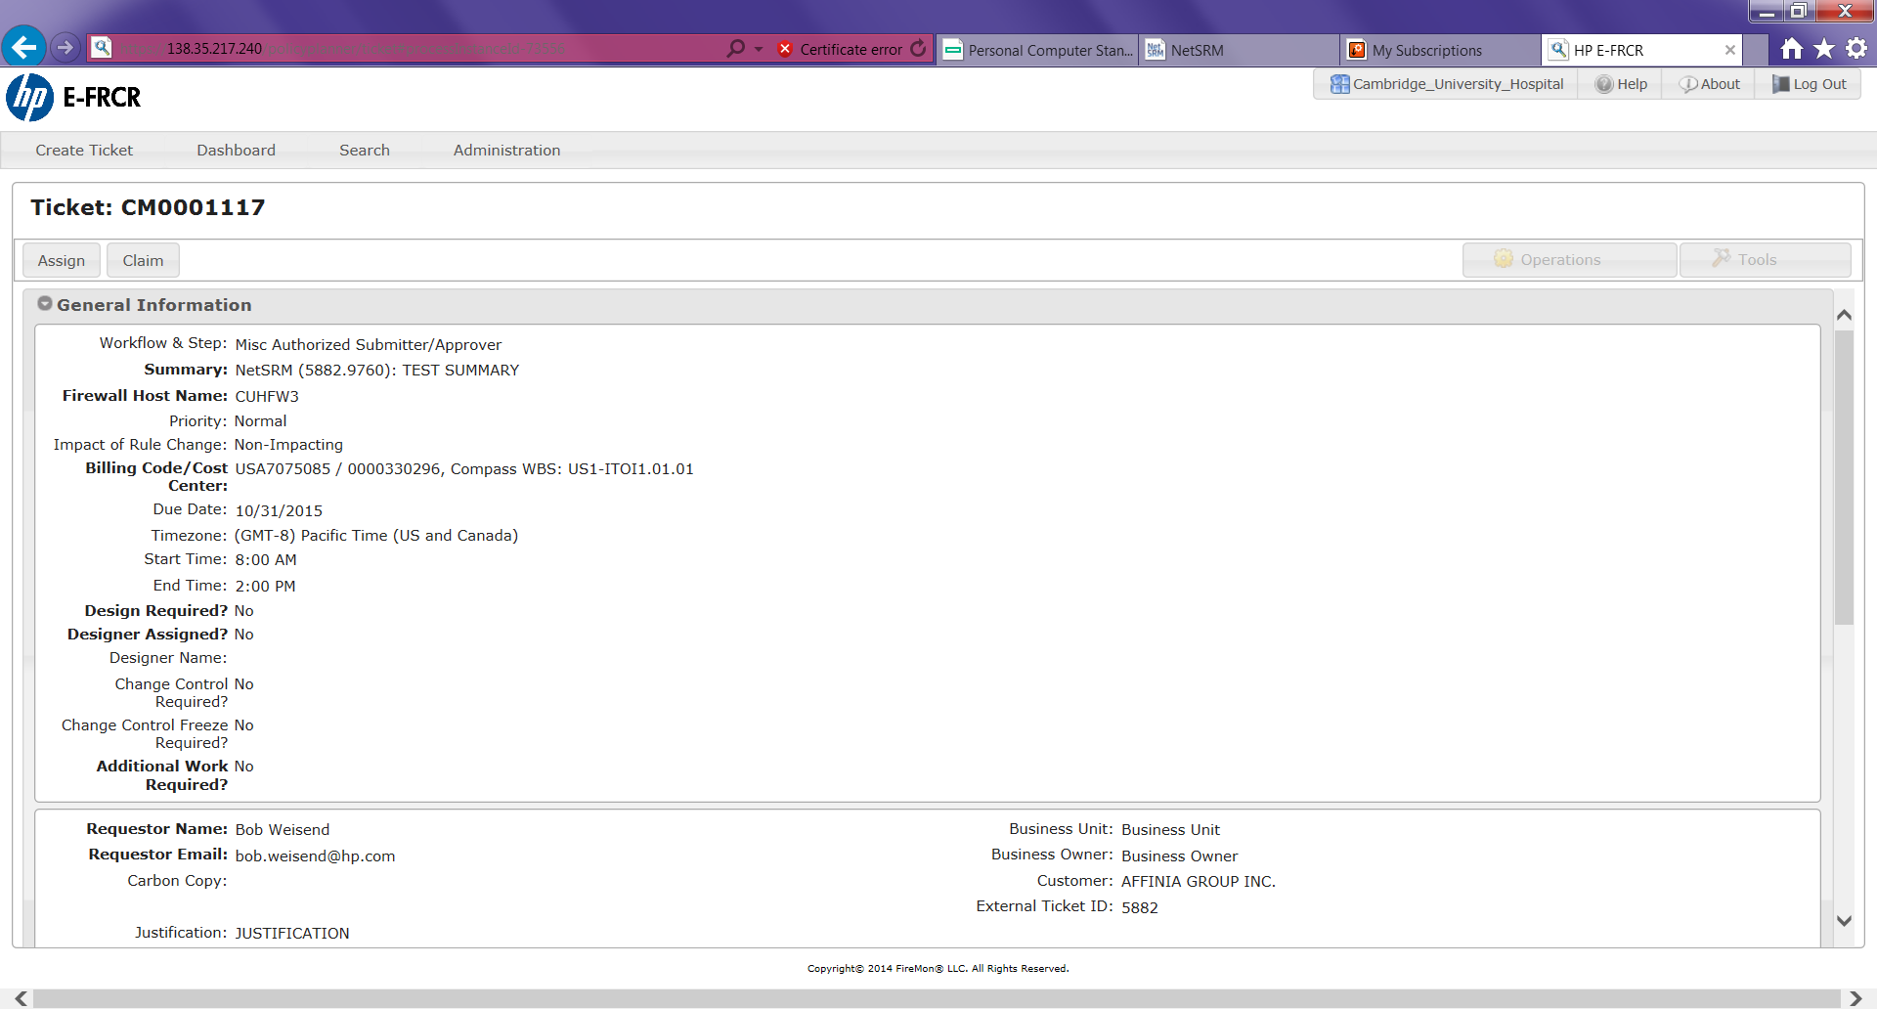

NetSRM interfaces with another ticketing system that the Firewall Administrators use (“Firemon”). When a firewall ticket is created in NetSRM, the data is sent to Firemon via RESTful APIs. The example above shows a ticket that was created from an API call originating from NetSRM. A separate API call could send/retrieve a binary attachment (e.g. Word, PDF).

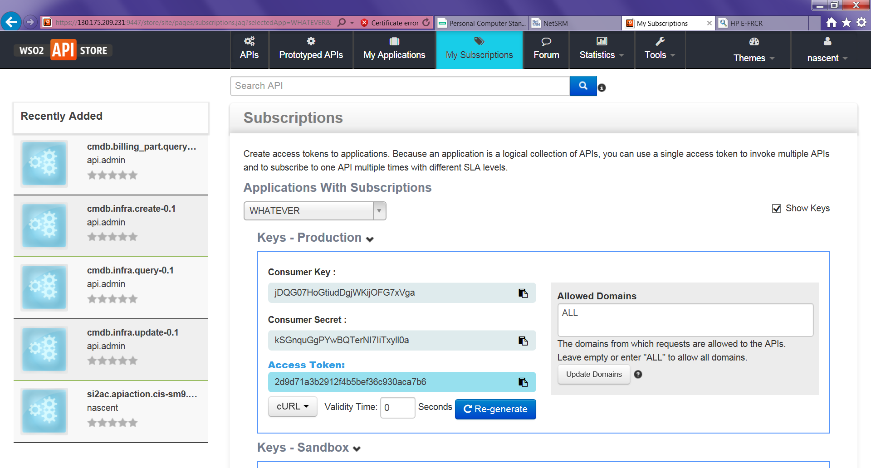

NetSRM API calls were made through a third-party application (WSO2’s “API Gateway”), which provides additional services such as authorization, throttling, logging and reporting. The above example is for an API that facilitates exchanges with HP Service Manager.

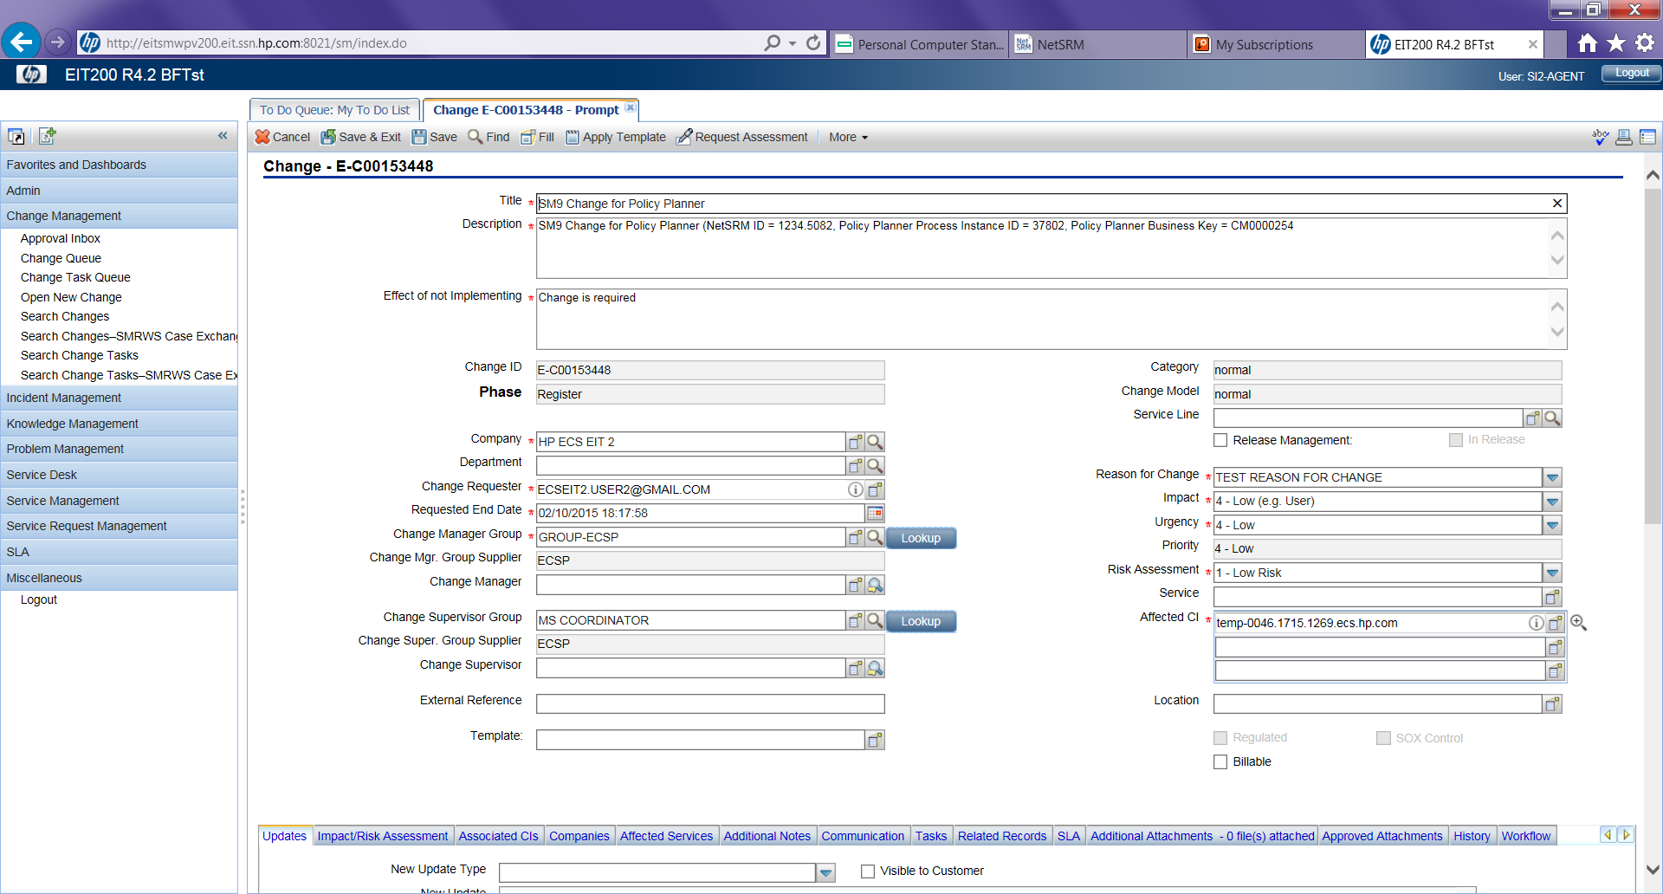

The above screenshot shows a sample Change Management ticket originating from NetSRM and subsequently sent to the HP Service Manager application using a RESTful API. Before this automation, the NetSRM user would have to email a Service Manager user, who would then have to manually create this ticket. This automation saved many man-hours and reduced time to completion.

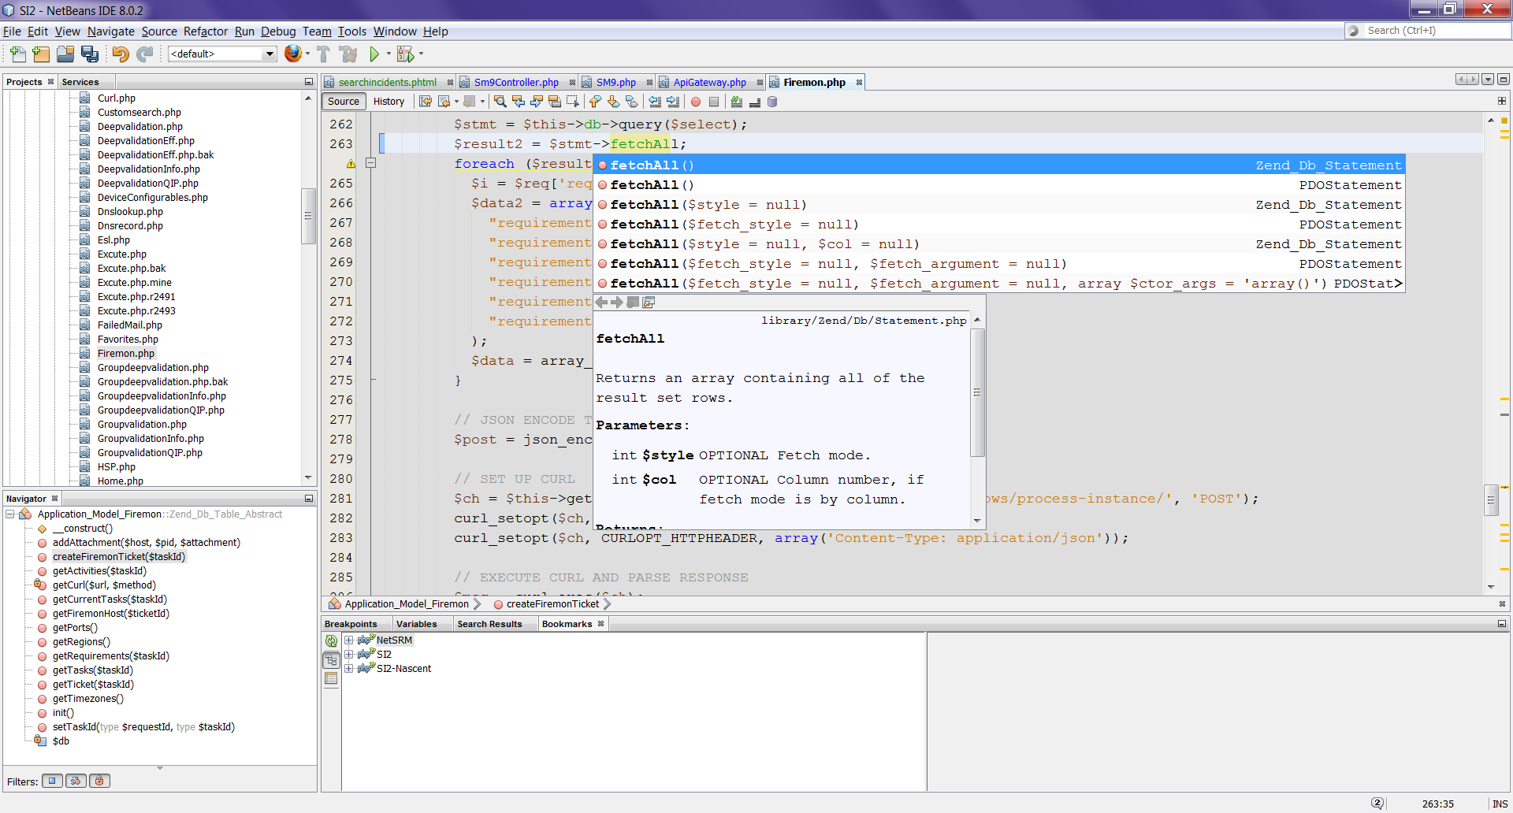

I used the NetBeans 8.0.2 IDE for my developer sandbox. It supported the Zend framework, the XDEBUG Extension, and all the usual IDE stuff (auto-complete, breakpoints, watches, bookmarks). It also integrated with our source control (SVN) for inline diffs, merging and resolving conflicts.